Customer service call :- +1234567890,+9876543210

Lorem ipsum dolor sit amet, consectetur adipiscing alit sed do

Euismod tempor incididunt ut labore et dolore magna aliqua.

WORLD 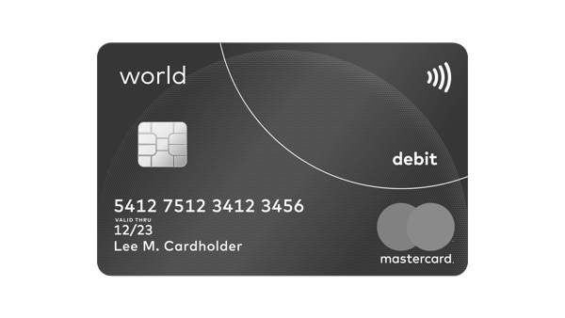

 debit

5412 7512 3412 3456

VALID THRU

12/23

Lee M. Cardholder mastercard

mastercard

123